User Manual for CMS Core

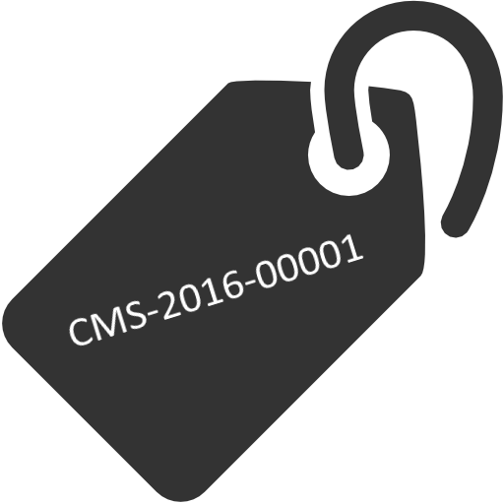

By Alexandre Realinho in conjunction with Caixa Mágica

Index

Installation Process 3

Menus 4

CMS Core 4

CMS Types 4

Credits 5

# Installation Process

To install the module CMS you first need the following dependences enabled in your Drupal 7 site.

* PHP(included in the Core);

After installing/enabling these modules, download and install the module, then check if all the dependences are enabled.

The only permission that the module installs is the “Administer CMS” permission that should be only available for administrators to alter custom types.

After this you can encounter the menus in “[your site]/cms”, you can include a link for entering the main menu of the module.

# Menus

## CMS Core

The heart of the module, here you can add remove and edit records of the types that exist and the types that the admin has created.

It has available a mini menu to add records to the table and a list of all the records in the table.

You can filter by the type, when doing this, the table shall change for the user to see the specific fields for each type.

## CMS Types

The back end of the heart, you can add new types and alter them, it also tells if a type has any records.

You need the permission of “Administer CMS” to view this menu.

# Credits

This manual was developed by Alexandre Realinho with the help of Caixa Mágica if you use this module in your site please credit the people you made this module and manual.